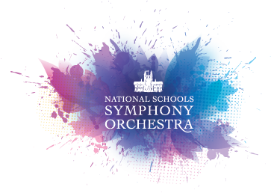
TASTER DAY
Sunday 27th January 2019 at Malvern College
NSSO Orchestras - Join us for a programme of coaching and rehearsal. This is the ideal way to find out about NSSO and our Summer course (14 – 21 July 2019) or even just to enjoy aspirational music-making with our team of instrumental tutors, led by our Artistic Director, John Madden. Our NSSO orchestras are defined by musical ability and age, and are open to talented musicians aged 9–19, of grade 3 standard and above.

New for 2019 ~ The NSSO Chorus enjoy a day of singing coaching with our chorus master Jonathan Brown. A taster to find out if our summer course is for you. Open to enthusiastic choral singers aged 11-19.

The Taster Day will end with an informal concert to which parents and friends are invited.

Simply complete the form below and return it to us by: Thursday 17th January 2019.
---------------------------------------------------------------------------------
NSSO Taster Day at Malvern College
Sunday 27th January 2019 09:30am to 4:30pm. Cost – just £20*.
*If you decide to apply for our summer course we will discount your course fee by £20.

Child’s Name
Age and gender
School attended
Interested in NSSO Orchestra or
The NSSO Chorus – please state
Instrument
Current standard
Parent/Guardian’s name
Parent email & phone no

Please pay £20 by bank transfer or by cheque (made payable to Malvern College with your surname & ‘NSSO Taster Day’ on the reverse).

Payment by bank transfer:
Account Name: Malvern College
Sort Code: 30-95-41
Account Number: 00005122
IBAN: GB98LOYD30954100005122 Swift Code: LOYDGB2L BIC: LOYDGB21139
Please ensure you add under ‘payment reference’ your surname/NSSO Taster Day

Return to NSSO, Malvern College, College Road, Malvern WR14 3DF
or by email to hello@nsso.org.

Full details of the day’s programme will be sent out the week before. Malvern College reserves the right to cancel or amend the arrangements if necessary. Fees will only be refunded if the event is cancelled or we are unable to offer an applicant a place for whatever reason.

Full details about NSSO can be found on our web site www.nsso.org.

